DOE | BUCK | DUE | RESERVATIONS  COMMENTS
CH Proctor Hill Farm BB Charivari E90  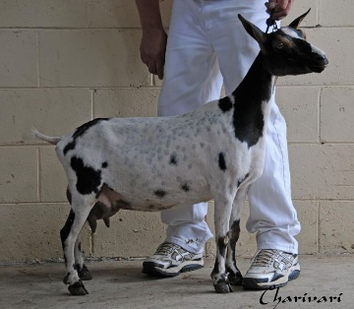 | J-Nel’s Bop Shoo Bop  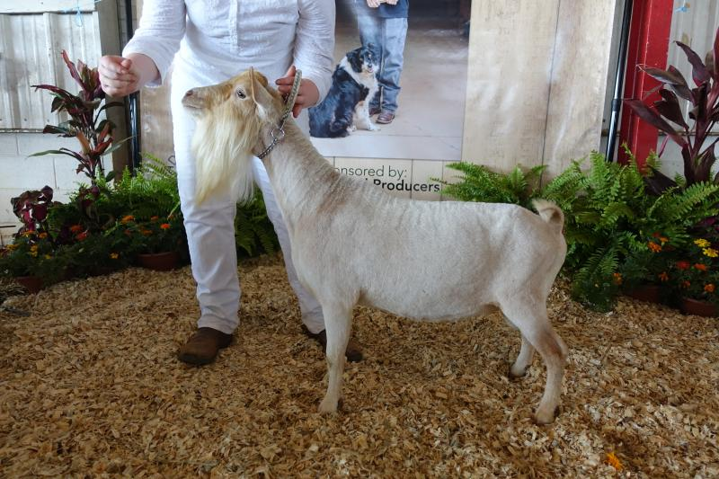 | 4.4.18 | All kids retained/reserved
Doublegate MB Chanel | Celia Creek Captain America  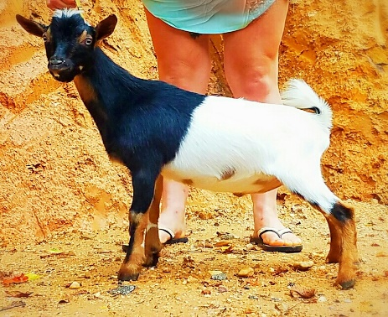 | Planned April 2018 | Moonspots/Blue eyes possible
Little Tot’s Estate Sephora | J-Nel’s Bop Shoo Bop | Planned May 2018 | Moonspots/Blue eyes possible
Little Tot’s Estate Lime A Rita | J-Nel’s Bop Shoo Bop | Planned May 2018 | Moonspots/Blue eyes possible

Cool Springs TA Passion | Celia Creek Captain America | Planned June 2018 | Moonspots/Blue eyes possible
Little Mesa Instant Alibi | Little Tot’s Estate Lentago  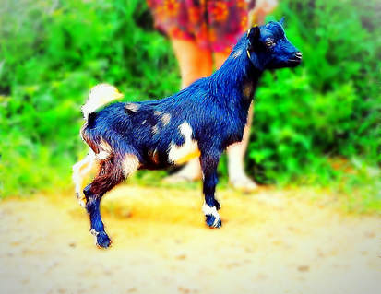 | TBD | Moonspots/Blue eyes possible

